The Sancta Maria Salus Populi Romani Icon

History of the Icon
Sancta Maria Salus Populi Romani is the name given to an icon (portrait painting of a saint) of the Blessed Virgin Mary holding Her Son Jesus. The name of the icon can be translated into English as “Blessed Mary, Protectress,” or “Health,” or “Salvation of the People of Rome.” The painting dates to at least 590, perhaps earlier. The artist is anonymous, but the icon is known as one of the “Miraculous Icons” attributed to St. Luke, who wrote the Gospel of Luke and the Book of Acts. St. Luke is the patron saint of artists.
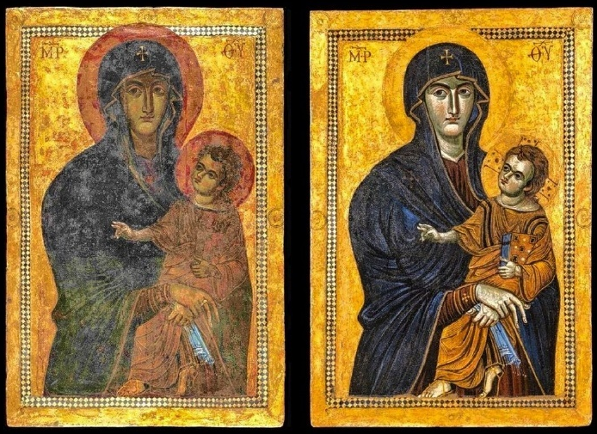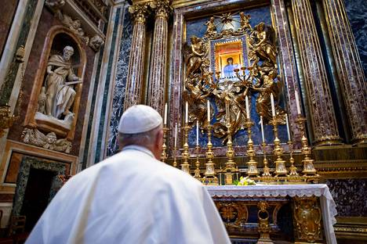
Above: Left, before restoration; Right, after restoration; Pope Francis before the icon in the Basilica of Saint Mary Major.
According to most histories, in 590, the Eastern Roman Emperor Theodosius sent this icon of Mary and Jesus to Pope Gregory in Rome. It soon played an important role in the lives of the people of Rome.
In 593 the “Black Death” plague broke out in Rome, killing many thousands. Pope Gregory begged for the intercession of the Blessed Virgin Mary by leading a procession of her icon through the streets of Rome. The plague was so horrific, even some of those walking in the procession died on the way. On a bridge over the Tiber River, the Pope looked up and saw over the Castel Sant Angelo, a vision of an angel wiping blood from his sword and placing the sword in its scabbard. The plague ended at that moment. To commemorate the deceased and Pope Gregory’s vision, a marble statue of an angel with a sword was erected on top of Castel Sant Angelo in 1536. In 1753, it was replaced with a bronze statue of the same subject which is still there today.
Centuries after Pope Gregory the Great’s procession, in 1837, Pope Gregory the XVI venerated the icon to protect Rome during a cholera epidemic. Other Popes have venerated the icon during plagues and threats from enemies for the protection of the city. This is how the icon received its honorific name.
It is the favorite icon of Pope Francis who commissioned it to be restored. In 2018, on January 28, the feast day in Rome of Sancta Maria Salus Populi Romani, the icon was presented to the Pope and processed to its setting in the Basilica of St. Mary Major.
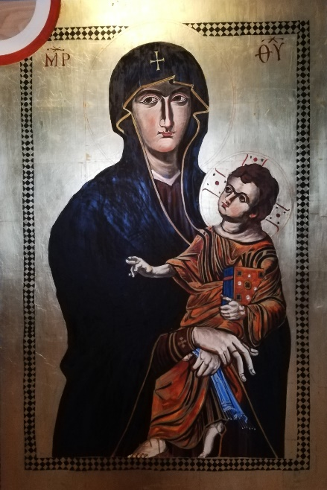
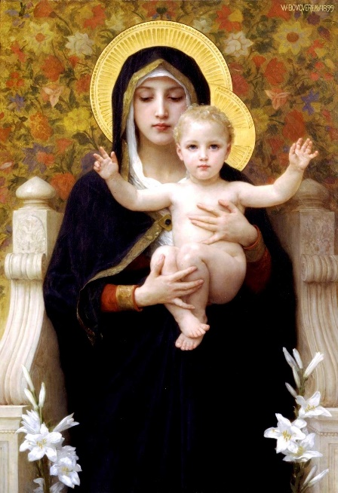
The word “icon” is from the Greek “eikon” meaning “image.” Icons are a major art form, or art genre (jzahn-reh,) in Churches of the Eastern tradition. Eastern Churches venerate (honor) icons in their Liturgies. The interiors of Eastern Catholic and Orthodox churches are often highly decorated with icons.
There are notable differences between an icon and a realistic portrait painting. Although icons have lines and shadows to indicate form, the figures appear flatter compared to the more rounded forms of realistic portraits. (Compare the two pictures above.) The faces in icons are stylized, with enlarged eyes, long noses and tiny mouths. The backgrounds are often a flat field of gold. Gold leaf is used to symbolize the eternal glory of the holy people in icons who are now with God in heaven. True icons depict only those who are recognized by the Church to be with God in heaven. Icons can be thought of as “windows into heaven.”
Bouguereau, Madonna and Child, 1899

Rochon, Sancta Maria, 2019
Icons are not meant to show us an actual likeness of a person. Their purpose is to remind us of the virtues of the saint shown. When we venerate an icon, we remember the lives of the saints before us who have obtained an eternal reward. Icons inspire us to turn away from sin and live as the saints lived, so that we too may reach heaven.
How “Sancta Maria Salus Populi Romani” was Made
This icon was painted on solid wood about one and a half inches thick and about 48 inches tall x 30 wide. Icons were usually painted on solid wood planks joined edge to edge with dowels. After this support was constructed, it was covered with many layers of gesso. Gesso is a kind of thick paint made with glue and chalk, marble dust, or plaster. The layers of gesso are sanded to give a smooth, white ground, or surface, for painting. Finally, the areas to be covered with gold leaf are given an additional ground made of red clay and glue called bole. On my copy of the icon shown above, I have left the layers of bare wood, gesso, and bole exposed in the upper left corner.
To apply the gold leaf, glue is brushed on the areas of clay bole ground. Gold leaf is very finely hammered gold. Fragile, extremely thin sheets of leaf are carefully laid down on the glue and burnished with an agate stone. Painting the saint’s image can now begin.
Most ancient icons were painted with a medium called egg tempera. It is made, as you may have guessed, from chicken eggs. Dry pigments are mixed with the yolk of an egg and applied to the painting with a small brush. Egg tempera dries quickly and is not readily blended on the painting’s surface. Therefore, many smaller brushstrokes are necessary to create subtle shifts of color or shading. After the paint has dried for several weeks, it is buffed to a low sheen or varnished.
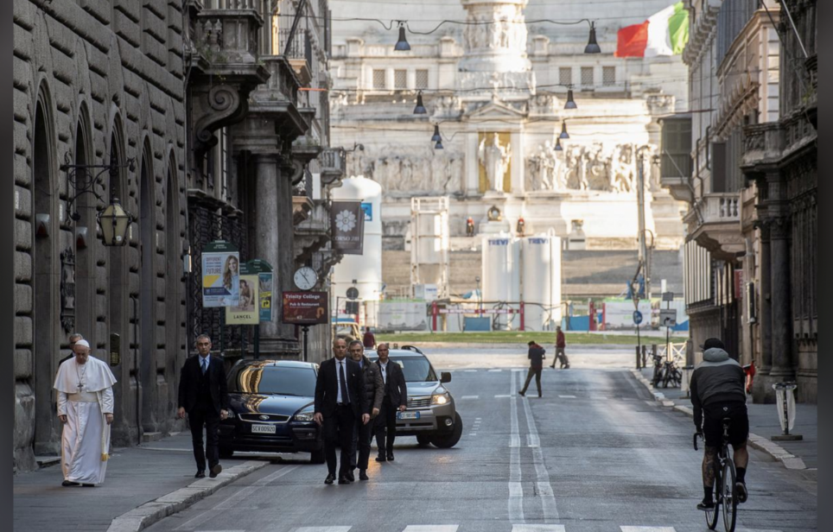
Icons have a long history with both the Greek (Eastern) and Latin (Western) Churches. They may look strange to us, being used to photos and realistic art. However, knowing the devotional purpose of “iconography,” we can appreciate icons for symbolic meaning as windows into heaven.
The people of Rome have attributed another title to their beloved icon. She is now known also as, “Sancta Maria Salus Populi Mundi” – “Holy Mary, Health and Salvation of the People of the Whole World.” As we endure the present inconvenience and uncertainty, let’s remember the suffering of the people of Italy. Let’s offer prayers for those who have already died, those suffering who have no one to care for them, and for those working to care for so many sick.
Pope Francis retraces the steps of Pope Gregory the Great through Rome in the procession of 593.
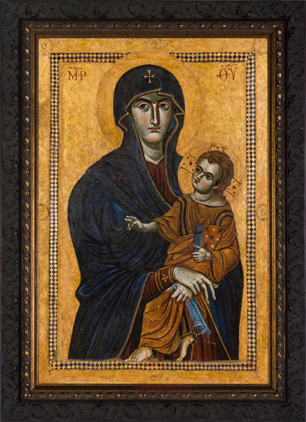
Sancta Maria Salus Populi Mundi - Ora Pro Nobis

